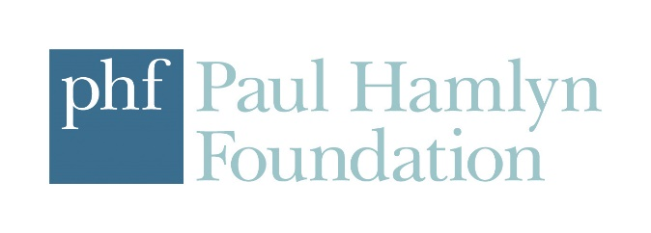

Artists from BAME backgrounds
Seed commission call-out

Spring 2018
With the support of the Paul Hamlyn Foundation, Camden People’s Theatre offers six seed commissions annually to artists from BAME backgrounds, to support the development of innovative new theatre projects. Two of these will be offered in Spring 2018: successful candidates will receive £750, one week’s rehearsal space, and the opportunity to present a ‘scratch’ performance (up to 25 minutes long) as part of our artistic programme. These commissions are being offered to artists of colour in recognition of the fact these artists are currently underrepresented in contemporary theatre.

What we’re looking for:
- New work, particularly work of social, cultural of political pertinence
- Unconventional and innovative work; work that’s doing something unexpected with the artform
- Devised, self-made and solo work
- Off-site work
- Interactive work
- Live art / cross-disciplinary work
Please bear in mind, we are unlikely to consider 'plays' as traditionally understood, 'new writing', formally conventional work, straight monologues, or any work made according to the usual writer-director-actor hierarchies. We cannot accept scripts as part of your application.

What we’re offering:
- £750 seed commission
- Marketing support, inclusion in brochures (where possible), website, social media activity
- Basic technical support
- One week of rehearsal space in May-June 2018 and a performance in week commencing June 11 as part of a CPT Big Bang scratch night
- Ongoing development opportunities – we hope that seed commissions lead to longer-term relationships with artists, and to be able to offer your projects further support

If you would like to submit a project proposal, please complete the online application form. We are unable to accept CVs, portfolios, scripts or anything other than our formatted application form.

Deadline for submission is Mon 26 February, 10am
Please contact James Cross james@cptheatre.co.uk if you have questions.

