The Difference Engine
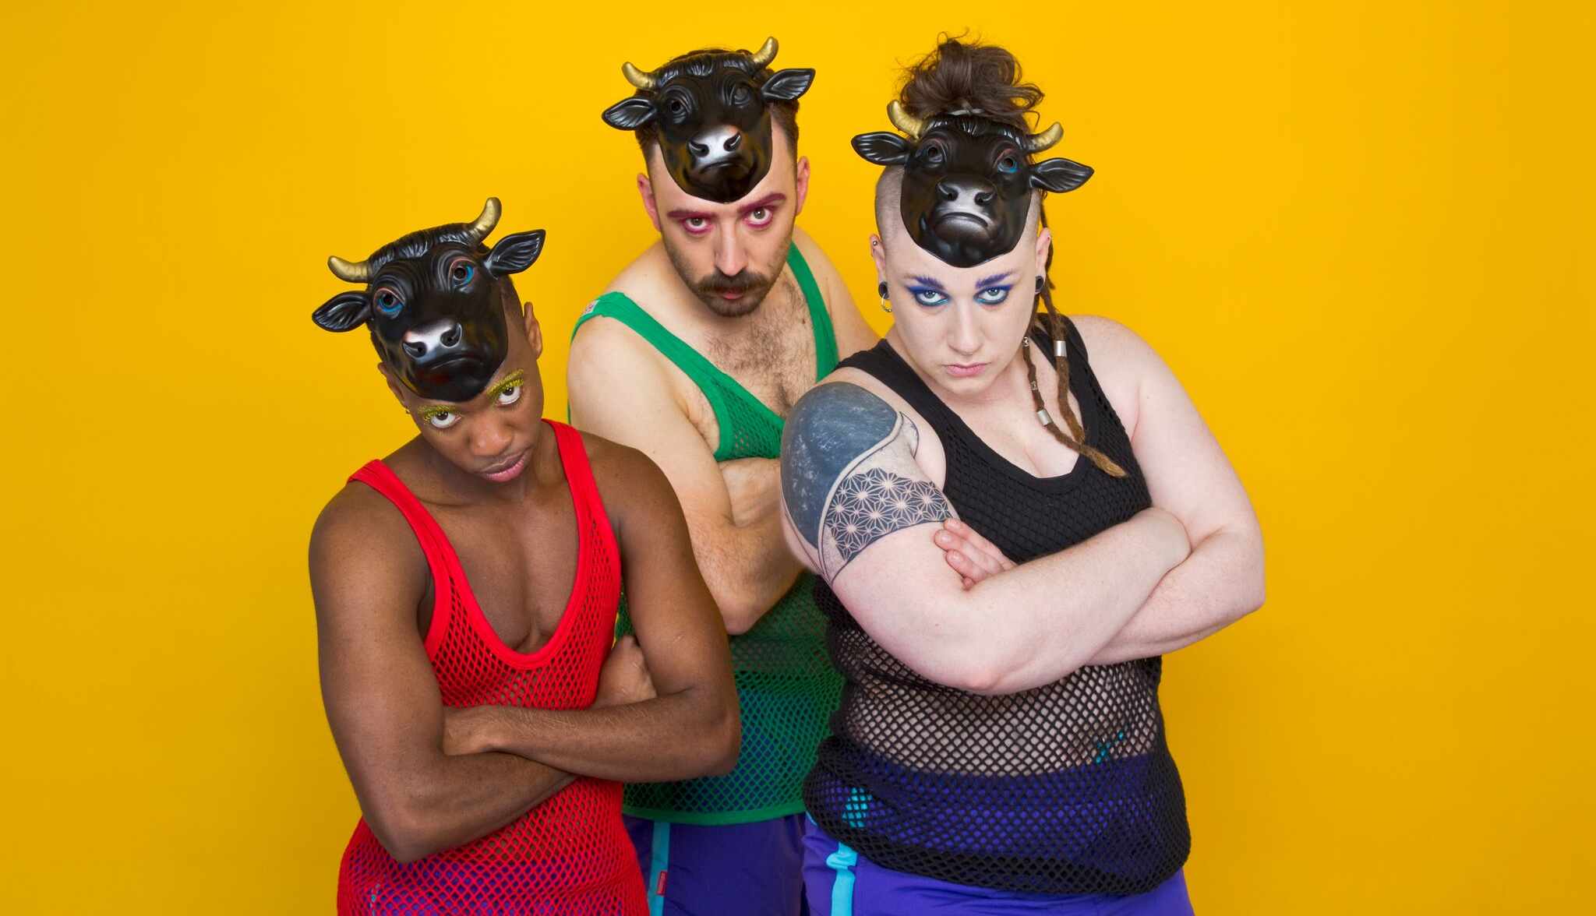
Every performance of BULLISH will be captioned using hand-held captioning equipment for deaf, and hard of hearing audiences called The Difference Engine. This will make the show more accessible for d/Deaf and hard of hearing audiences, as well as those who struggle with spoken English.

Here's what you need to know:

There are two ways you can use the Difference Engine:

1.
- The Difference Engine can be downloaded onto your smart phone or tablet before the show
- Please try to arrive 30 minutes before the show so that we have time to give clear instructions to each individual audience member
- The captioning is streamed directly to your phone so we recommend that your mobile device is fully charged prior to the performance
- There will be battery packs available for audience members whose phone is low on battery
- This is not a replacement for BSL and we appreciate it will not be suitable for all d/Deaf audiences
2.
- Email access@talkingbirds.co.uk and you will be sent instructions on how to download the app
- The App is initially only available on iOS (Apple) devices running iOS 8 or above, but an Android version will be available soon.
- Please try to arrive 30 minutes before the show so that we have time to give clear instructions to each individual audience member, should you experience trouble with the app.

If you want to use The Difference Engine please inform Box Office when you arrive
We would really value your feedback and support in making more of our work d/Deaf accessible, so if you use The Difference Engine, please let us know what you think after the show.
Here is a review of The Difference Engine from an audience member who saw Milk Present’s previous show JOAN at Derby Theatre in 2016:

"I was most impressed in the high quality standard of the captions and how perfect it fitted into the small scale one woman monologue performance of Joan.
As a hearing aid user who lip reads, I found this technology allows me to fully understand the whole performance with ease.
I found I could read quickly ahead and to be able to watch the whole show in order to capture the emotions and the visual aspect of the character performance.
I have watched many stage close captioned which are often at the side of the stage and by the time I read them, I have missed the performance of the character. I found the large captions can be distracting the show.
I thoroughly enjoyed how the caption portrays the difference italics voices to present the various characters within the show and the description of the music genre.
The captions writing quality is a perfect colour contrast in Yellow and black was easy to read.
I most definitely would use this technology again as I feel I was in control of my access and it was discreet to have the options to glance and having the ability to read ahead. I felt integrated as there was humour, audience participation and emotions which I felt synchronised with rest of the audience instead of receiving the information second later on.
I am now a fan."

Additional information
The Difference Engine is developed by Talking Birds Theatre Company to provide access to experimental, small scale and site-specific performance. It broadcasts captions to smart phones and tablets.

