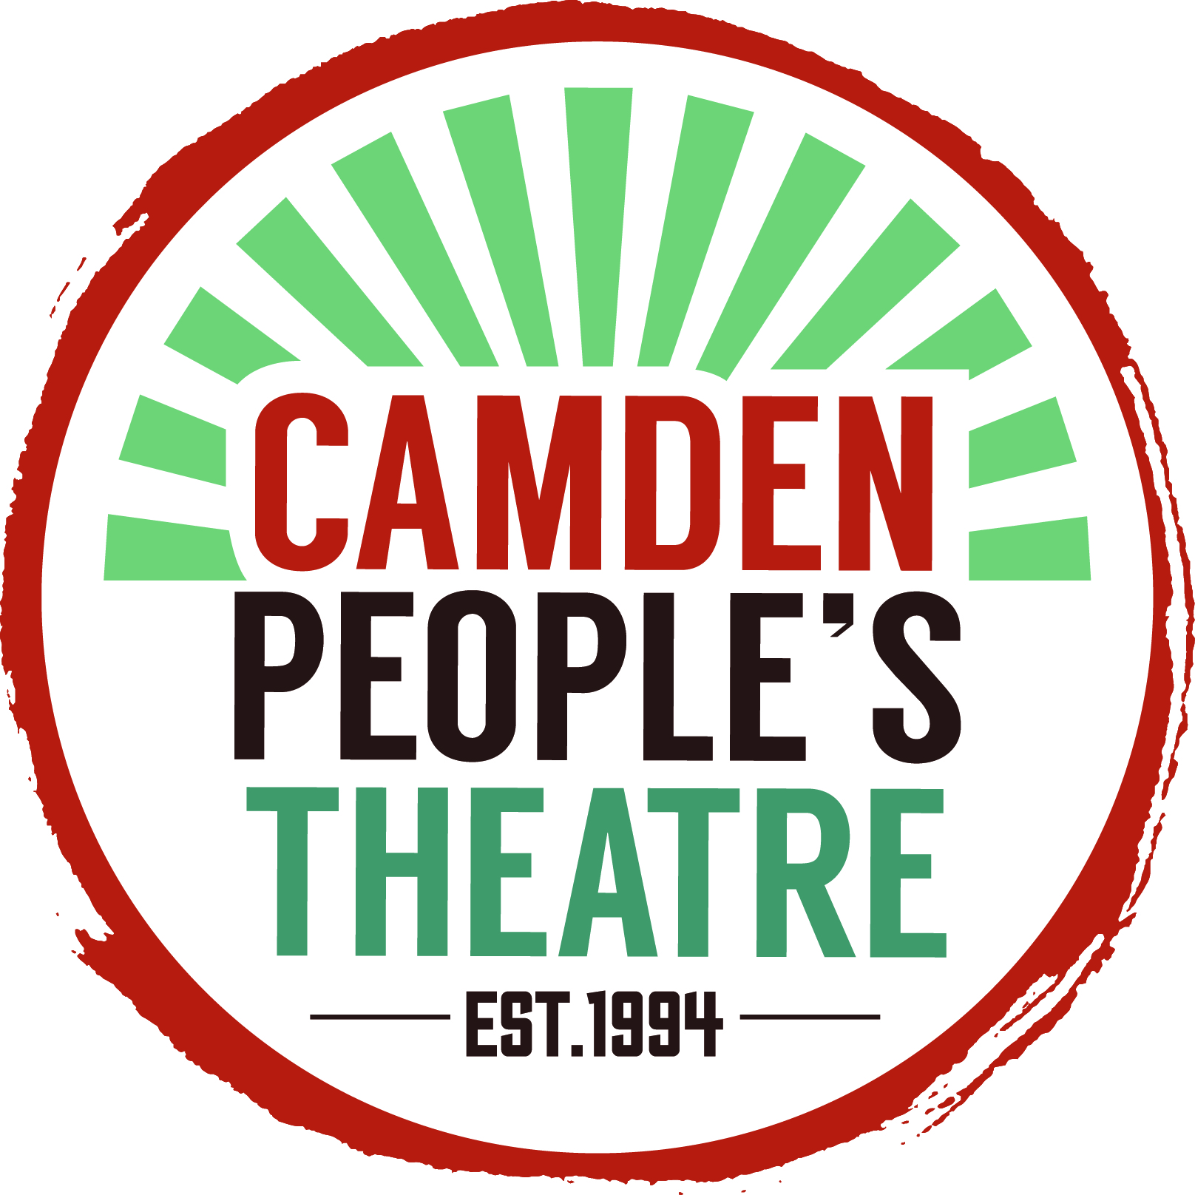
Application form
Come As You Are festival
Please note, we will only accept applications complete on this form, and are unable to accept scripts.
Contact and company information
Name of artist / company
Lead contact
Preferred pronouns for lead contact / company members
Website (if applicable)
Email
Phone no.
Where are you based?

Availability between 12 Sep -1 Oct

How do you / your company members identify?
Age/s of company
Ethnic group of company

Event information
Name of event
Number of performers
Stage of development - e.g. early scratch, work-in-progress, full production
Expected running time
One-line summary
London premiere?

Space requirements
Please check to indicate whether your event will ideally take place in our theatre; another, non-theatre space at CPT (e.g. basement space, foyer etc); or off-site.

Theatre space
Other space at CPT
Off-site / outdoor / other (please describe)

Technical information
Please indicate your tech requirements. In 'other', please notify us if your event involves e.g. liquids/food/mess; or anything else it may be useful for us to know in advance.

Lighting
Sound
Mics / stands
Set
Other

Max. 250 words about the artist/company: what you do and why; what work you've made, with whom & where

Max. 300 words about the performance you’d like to bring to CPT. (What makes it distinctive?)

Reviews / feedback from previous work

Please complete this form, turn into a PDF, and return to Anna O’Dell (anna@cptheatre.co.uk) by 10am, Mon 10 April. Please include links to supporting documentation (videos, images)– we will not be able to accept email attachments. We will accept your application as an accurate representation of the work you’re proposing, and of your availability. Late applications will not be accepted.
Unfortunately, due to the amount of applications anticipated, we are unable to notify or feedback to unsuccessful applicants.

